

SCHOOL OF COMPUTER APPLICATION
Department of MCA

ACADEMIC YEAR: - 2025-26(EVEN SEM.)
Project Synopsis
Name: Mayuri Turkane
Roll no: MCB24249
Name: Snehal Turkane
Roll no.: MCB24250

1. Title of the Project :

Campus Crave – Online Canteen Ordering System

2. Introduction:

In educational institutions, students often face long queues and delays while ordering food from college canteens. Traditional manual ordering systems are time-consuming and inefficient. There is no proper digital system to manage multiple canteens and their separate menus. The proposed project, Campus Crave – Online Canteen Ordering System, is a web-based platform that allows students to view menus of different canteens, place orders online, and reduce waiting time. The system provides a simple and user-friendly interface for browsing food items and ordering efficiently This project improves the overall food ordering experience within the campus and ensures better time management for students.

3. Objectives of the Project
- To develop an online platform for ordering food from multiple canteens.
- To display different menus for different canteens.
- To reduce waiting time and long queues.
- To provide secure user authentication (Login & Registration).
- To allow easy management of food items and prices.
- To enhance user experience with an attractive and responsive interface.

4. Scope of the Project:

Students can register and login into the system.

Users can select a specific canteen and view its unique menu.

Students can place food orders online.

The system can be extended to include payment integration.

The admin can manage menu items and canteens.

Future enhancement can include real-time order tracking.

5. Methodology:

The project follows an iterative development approach across six phases:
Phase 1: Requirement Analysis – Identifying campus pain points (line wait times, group payment issues).
Phase 2: System Design – Designing the MySQL relational schema and Group-Order logic.
Phase 3: Backend Development – Building RESTful APIs with Flask (Python) and implementing the KNN recommendation model.
Phase 4: Frontend Development – Creating the React.js UI with a focus on quick-order dashboards.
Phase 5: Integration & Testing – Testing the split-payment accuracy and ML prediction reliability.
Phase 6: Documentation – Preparing the final synopsis and system architecture reports.

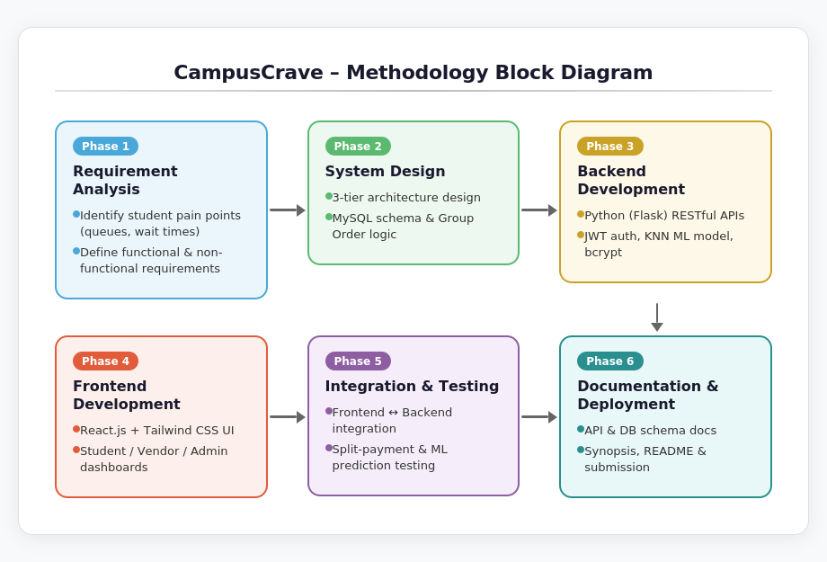

6. Flow Chart:

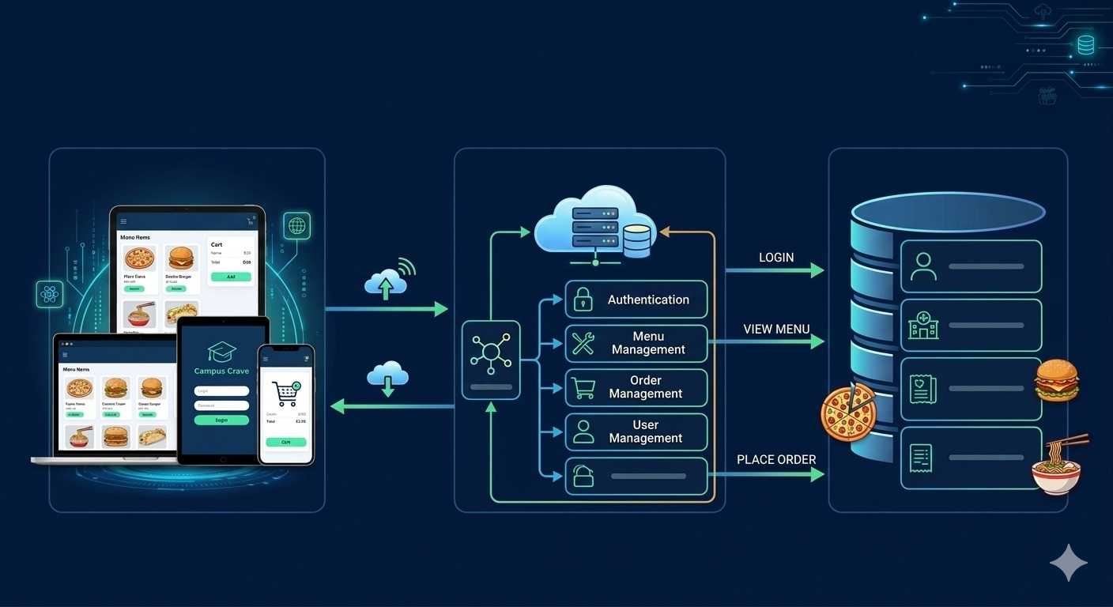

7. Feasibility Study

1. Technical Feasibility
The project uses widely available technologies such as React, JavaScript, and Tailwind CSS. It can run on standard computer systems without requiring special hardware.
2. Economic Feasibility
The project uses open-source technologies and does not require licensing costs, making it cost-effective.
3. Operational Feasibility
The system is user-friendly and requires minimal training for students and administrators.
4. Schedule Feasibility
The project can be completed within the academic semester duration using modular development.

8. Expected Outcomes: The expected outcomes of the project include:
- A working web-based campus canteen ordering system.
- Easy access to multiple canteen menus.
- Reduction in long queues at canteens.
- Improved user experience for students.

9. Project Plan and Timeline

Phase | Activity | Duration
Phase 1 | Requirement Analysis | Week 1
Phase 2 | System Design | Week 2
Phase 3 | UI Development | Week 3–4
Phase 4 | Frontend Implementation | Week 5–6
Phase 5 | Testing and Debugging | Week 7
Phase 6 | Final Deployment | Week 8

10.Conclusion

Campus Crave provides a modern and efficient solution for campus food ordering. By digitalizing the canteen system, it reduces waiting time and improves convenience for students. The platform allows different menus for multiple canteens and can be extended in the future with payment integration and admin management features. Overall, the system enhances operational efficiency and user satisfaction within the campus environment.

Signature of the Student | Date of Synopsis Submission
Signature of the Faculty | Date of Approval

